**Power BI Assignment 2**

**1- Explain the advantages of Natural Queries in Power Bi with an example?**

**Ans**-A natural language query is input that consists solely of terms or phrases spoken normally or entered as they might be spoken, without any non-language characters, such as the plus symbol or the asterisk, and without any special format or alteration of syntax. Natural language queries may be conducted through a text or voice interface.

Natural language processing (NLP) makes it possible for software to “understand” typical human speech or written content as input and possibly respond to it, depending on the application. A virtual assistant, for example, is designed to respond to spoken input or text. However, no software is capable of deriving meaning from human language as it is spoken, so NLP involves processes to translate language between the two.

example: - A natural language query is input that consists solely of terms or phrases spoken normally or entered as they might be spoken, without any non-language characters, such as the plus symbol or the asterisk, and without any special format or alteration of syntax.

**2- Explain Web Front End (WFE) cluster from Power BI Service Architecture?**

**Ans**-The Power BI service architecture enables the user to create and access various reports and dashboards from the client platforms. The user needs to request or interact with the Power BI service to get data on the Power BI.

The Power BI implementation includes two major clusters. Such as a Web Front End (WFE) cluster, and a Back-End cluster.

The Web Front End cluster manages the initial connection between the back-end cluster and the clients. It uses AAD (Azure Active Directory) to authenticate clients. Moreover, it provides various tokens for connecting clients to the Power BI service. Besides, Power BI also uses the Azure Content Delivery Network (CDN) to distribute the content efficiently. Besides, it uses ATM (Azure Traffic Manager) to distribute content to users based on various geographical locations.

The Web Front End (WFE) cluster. The WFE cluster manages the initial connection and authentication to the Power BI service.

The Back-End cluster. Once authenticated, the Back end handles all subsequent user interactions. Power BI uses Azure Active Directory (Azure AD) to store and manage user identities. Azure AD also manages data storage and metadata using Azure BLOB and Azure SQL Database, respectively.

The WFE cluster uses Azure AD to authenticate clients and provide tokens for subsequent client connections to the Power BI service. Power BI uses the Azure Traffic Manager (Traffic Manager) to direct user traffic to the nearest datacentre. Traffic Manager directs requests using the DNS record of the client attempting to connect, authenticate, and to download static content and files. Power BI uses the Azure Content Delivery Network (CDN) to efficiently distribute the necessary static content and files to users based on geographical locale.

**3- Explain Back End cluster from Power BI Service Architecture?**

**Ans**-The Back-End cluster determines how authenticated clients interact with the Power BI service. The Back-End cluster manages visualizations, user dashboards, datasets, reports, data storage, data connections, data refresh, and other aspects of interacting with the Power BI service. The Gateway Role acts as a gateway between user requests and the Power BI service. Users don't interact directly with any roles other than the Gateway Role. Azure API Management eventually handles the Gateway Role.

The Back End Cluster is useful to maintain various reports, storage, data sets, and other services under Power BI. In the BEC, the client has only two points to interact directly with the information or data. These are the Gateway Role and Azure API Management. Moreover, these components are useful for various services like load balancing, authentication, and routing, etc.

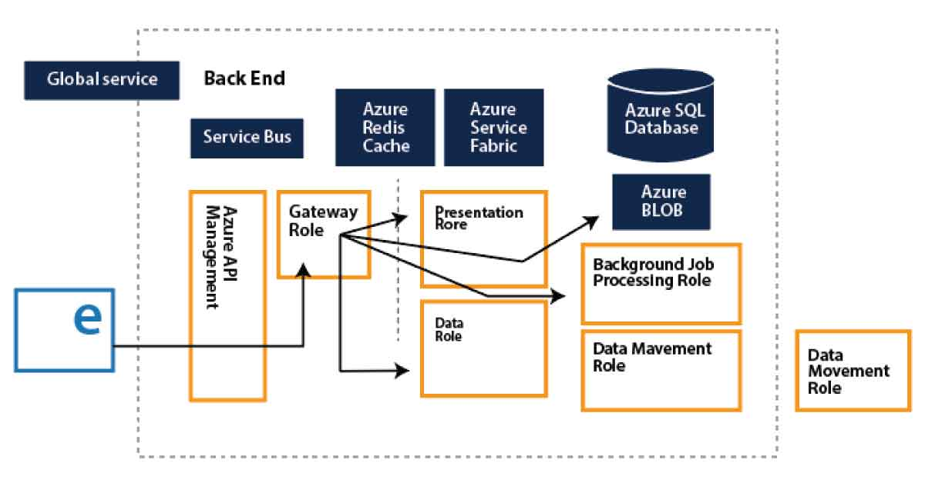

**4- What ASP.NET component does in Power BI Service Architecture?**

Ans-The WFE cluster provides the user's browser with the initial HTML page contents on site load, as well as pointers to CDN content used to render the site in the browser.

A WFE cluster consists of an ASP.NET website running in the Azure App Service Environment. When users attempt to connect to the Power BI service, the client's DNS service may communicate with the Azure Traffic Manager to find the most appropriate (usually nearest) data centre with a Power BI deployment. For more information about this process, see Performance traffic-routing method for Azure Traffic Manager.

Static resources such as *.js, *.CSS, and image files are mostly stored on Azure Content Delivery Network (CDN) and retrieved directly by the browser. Note that Sovereign Government cluster deployments are an exception to this rule, and for compliance reasons will omit the CDN and instead use a WFE cluster from a compliant region for hosting static content,

**5- Compare Microsoft Excel and Power Bi Desktop on the following features:**

Data import

Data transformation

Modelling

Reporting

Server Deployment

Convert Models

Cost

**Ans**- Microsoft Excel is an office 365 product from Microsoft. It was initially released in the year 1985 under Microsoft Corporation and a current version is Excel 2018. Excel is a type of spreadsheet application that captures data in the form of rows and columns. A recent version of Excel is enriched with a wide variety of features and applications. You can turn data into insights. Power BI is a business analytics tool from Microsoft. Power BI is a collection of software services, apps, and connectors that work together to turn your unrelated sources of data into interactive insights, coherent and visually immersive. Power BI easily connects to different data sources of any size.

**1- Data import**- Power BI can connect to a large number of data sources, while Excel's connectivity capacity is limited. Also, unlike Excel, Power BI can be easily used from mobile devices. Power BI has faster processing than Excel. Power BI dashboards are more visually appealing, interactive and customizable than those in Excel.

**2-Data transformation**-Power BI is a set of tools, software services and business intelligence applications oriented to business. In other words, Power BI is a platform with a more specific objective than Excel —data processing in business environments— although it can also be used in other sectors. One of the great advantages of Power BI is that it can connect with many data sources of many sizes: Excel spreadsheets, relational and non-relational databases, cloud services, files in different formats, Big Data tools, web applications, etc. In addition, it has high graphic and data transformation capabilities in reports, dashboards and customized, attractive, interactive and easily understandable visualizations.

**3-Modeling**- In Excel Ability to work on simple and structured data model on the other hand in power bi ideal for building data easily

**4-Reporting**- In excel simple and less attractive reports than those of power BI, in power BI more beautiful, personalized, attractive and interactive reports.

**5-Server Deployment**-Deploy Excel Services is difficult to deployment and power BI deployment is easier to excel.

**6- Cost**- Excel has payment tool and its constable, but power BI it has free version and payable version.

**7-Convert Models**- in Excel convert data model through MDX Language, and in power bi DAX model is used.

**6- List 20 data sources supported by Power Bi desktop.**

**Ans**-The Database category provides the following data connections:

1.SQL Server database

2.Access database

3.SQL Server Analysis Services database

4.Oracle database

5.IBM Db2 database

6.IBM Informix database (Beta)

7.IBM Netezza

8.MySQL database

9.PostgreSQL database

10.Sybase database

11.Teradata database

12.SAP HANA database

13.SAP Business Warehouse Application Server

14.SAP Business Warehouse Message Server

15.Amazon Redshift

16.Amazon Athena

17.Google Big Query

18.Google Big Query (Azure AD)(Beta)

19.Vertica

20.Snowflake